Final Report

Quantitative: The following results were gathered from the Quantitative section within the survey posted.

Question: Was the Feedback provided enough to smoothly guide you into learning the safety procedure? 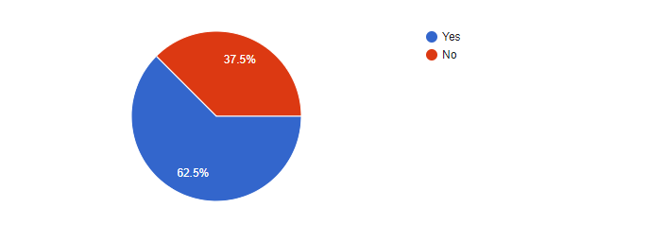

Question: Has the freedom of experimenting and testing while interacting aided you in getting familiar with the weapon both in the learning process and in the final reward section?

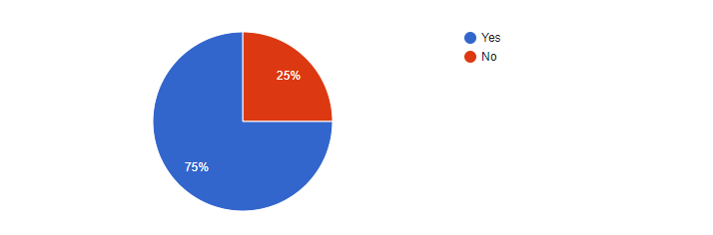

Question: Did the Reward Feature motivate you to keep on attempting

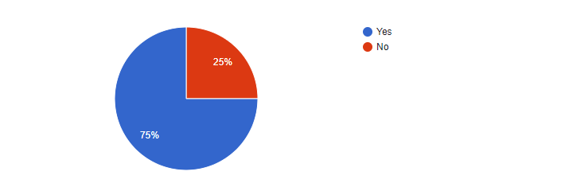

Description:

Such a survey was set up with these quantitative questions in order to figure out an estimate of the most efficient gamification elements amongst players. The tested gamification elements are feedback, the anticipated rewards, interaction and freedom of experimentation. The method of testing was taken from the each paper using quantitative data gathering to measure the efficiency of each element according to the different users participating. Such paper would be Analysis of Gamification Elements in the Virtual Learning Environment Context which uses the same technique to understand these concepts. In conclusion, these obtained result shall indicate an answer in reference to the gamification efficiency research questions.

The following tables were taken from the Prototype's Database.

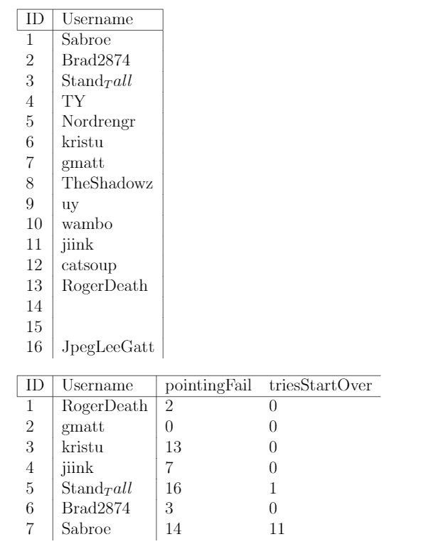

Description:

These tables were generated from the prototype built in regards to figuring out its efficiency in handling the learning experience by returning these variables. In order to understand who surpasses the learning experience and who doesn’t, the usernames where saved before and after if the user passes. Two other variables were added called pointingFail and triesStartOver. The variable pointingFail determines the number of times the user commits a safety violation involving firearm pointing while triesStartOver in its name identifies the number of times the user restarted the scene.

Qualitative: The following questions were taken from the survey.

Question 1: Can you give out a brief explanation about your learning experience while utilizing the VR Game?

• I already know all of the mechanics of the firearms in the game, but it was a nice change seeing something so simple, yet still very effective. I’m used to something like H3VR with extremely realistic firearm manipulation, but having what’s basically a point and click game is, I imagine, very handy for people only new to firearms and their functions.

• safety. essentially, keep the barrel pointed where you do not want to shoot and how to safely chamber a round and fire the gun

• During the experience I learnt safety precautions about gun handling that I didn't know before. On the other side, the gun play, controls and so on felt very good and satisfying which immersed me further to replay the game.

• From what I experienced, the game was used in such a way as to teach the user about gun safety, and afterwards giving the user the ability to test out different firearms.

• I tried following the guide but I could not manage

• I was taught how to operate firearms with an emphasis on safety, and learned what attitude to have while handling firearms

• Didn't learn much really

Question 2: Comments or Suggestions?

• Charging the bolt on the bolt action can be a bit iffy, needs to be a bit easier to pull down into it’s slot after racking it. Adding some sort of ping to hitting a target would make it slightly more rewarding to aim for the targets instead of shooting random things. Overall models could definitely be worked on, though you definitely know this already. The laser pistol also seems to not have infinite ammo, but reload itself after the mag is empty, and then continue firing. Racking the slide home after inserting a new mag can be glitchy for the M9, which leads to the user not knowing if the mag they just put in was full or empty. In terms of safety, there’s no real risk to not following correct safety precautions for all other firearms, and I know it’s supposed to be a sandbox at the end, but I think there should be specific training for the firearms before letting the user go crazy with them. One more tiny thing, maybe add a multiplier to throwing the grenade, as it’s hard to throw things very far in VR.

• some of the models (akm) with the magazine insert, will instantly chamber a round without you moving the bolt at all

• Create more lighting in the virtual environment because when trying to shoot at a distance the targets can be difficult to see and aim.

• I was unable to run the game using a Valve Index and SteamVR. It opens in desktop mode even when adding the game to steam and launching it from within VR mode

• Finished textures at the end would be nice.

• The guide started glitching

• Real well done! There are some slight inaccuracies, like you shouldn't be able to pull out the pistol magazine without using the mag release, and the pistol slide shouldn't automatically lock back if there's no mag inserted, and I think the AK's charging handle should go back further (i \*may\* be wrong about some of those as I haven't used real firearms, i just play H3VR a lot). Despite these, I think your program fulfills its purpose very well.

• Not very good communication. Sometimes when holding the first pistol down range it would randomly despawn from my hand. More feedback (audio maybe, spoken words) about what the player is supposed to be doing, and feedback when they are doing some thing wrong.

Description:

In regards to Qualitative data gathering, the users opinions, comments and sueggestions where taken in consideration by adding two alternate questions within the survey’s structure. One of which determines the user’s experience during the learning experience while the other one refers to any comments and or suggestions the user may have overall. In the end, these were used to thoroughly understand what the user went through in order to provide us the results. Gamification of a Software Engineering Course by Kay Berkling uses similar qualitative data gathering methods.